**String Slicing and Operations on Strings**

String Slicing

-- Python also allows a form of indexing syntax that extracts substrings from a string, known as string slicing.

-- If s is a string, an expression of the form s[m:n] returns the portion of s starting with position m, and up to but not including position n:

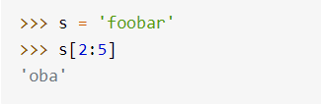

-- String indices are zero-based. The first character in a string has index 0. This applies to both standard indexing and slicing.

-- The expression s[m:n] will return a substring that is n - m characters in length, in this case, 5 - 2 = 3.

-- Omitting both indices return the original string, in its entirety. Literally. It is not a copy; it is a reference to the original string:

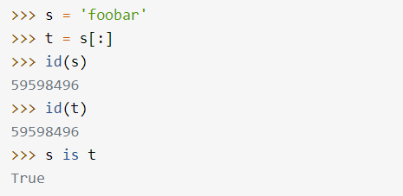

-- If the first index in a slice is greater than or equal to the second index, Python returns an empty string.

